**Project Design Phase-II**

**Data Flow Diagram & User Stories**

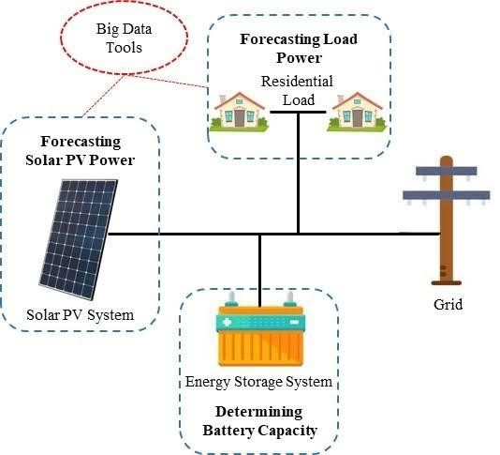

|  |  |
| --- | --- |
| Date | 20 September 2022 |
| Team ID | 62068211D555C508F8E4542C3732872A |
| Project Name | Solar panel forecasting |
| Maximum Marks | 4 Marks |

**Data Flow Diagrams:**

A Data Flow Diagram (DFD) is a traditional visual representation of the information flows within a system. A neat and clear DFD can depict the right amount of the system requirement graphically. It shows how data enters and leaves the system, what changes the information, and where data is stored.

Example: DFD Level 0 (Industry Standard)

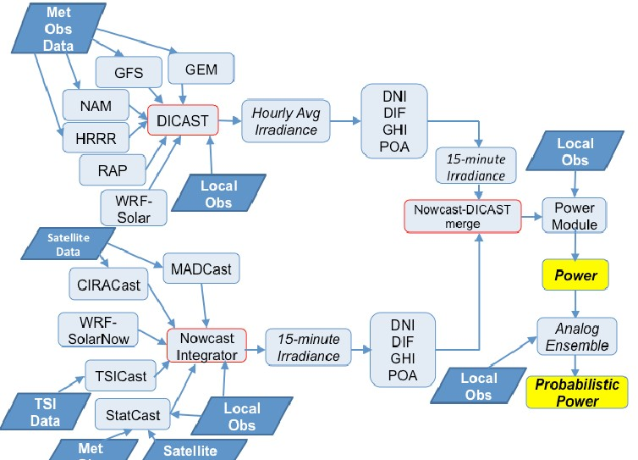

**User Stories**

|  |  |  |  |  |  |
| --- | --- | --- | --- | --- | --- |
|  |  | | | | |
|  | | Solar Panel Forecasting User Stories | | | | |
|  | | | | |
| : | | | | |
|  | | | | |
| **User Story** | **Role** | **Goal** |  | |
| US01 | Homeowner | To efficiently plan electricity usage based on next week's solar energy production forecast. |
| US02 | Solar Panel  Installer | To ensure optimal performance of customers' solar panel systems by receiving daily energy production forecasts. |

|  |  |  |  |  |  |  |  |  |  |
| --- | --- | --- | --- | --- | --- | --- | --- | --- | --- |
|  | | **User Story** | | **Role** | | **Goal** | |  | |
| US03 | | Energy Grid Operator | | To manage  electricity distribution effectively by having accurate monthly solar energy forecasts. | |
| US04 | | Researcher | | To analyze historical solar panel data and forecast trends in solar energy production. | |
| US05 | | Maintenance Technician | | To perform proactive maintenance by receiving real-time alerts when solar panel energy production is expected to drop. | |
|  | | **User Story** | | **Role** | | **Goal** | |  | |
| US06 | | BCGovernment Official | | To plan and optimize renewable energy  initiatives in the region using aggregated solar panel forecasts. | |